- Explain the concept of physical data independence, and its importance in database systems.
Ans) Physical data independence refers to the ability to change the physical storage structure or access methods without affecting the logical schema of database and application programs. The importance of this is that user can optimize the database for performance by adding indexes, changing file organizations or storage structures without requiring modifications of queries or system applications. This separation lets the database to be flexible, scalable and easy to maintain.

- Why database systems support data manipulation using a declarative query language such as SQL
Ans) SQL is called a declarative query language because the user can tell the database using SQL to get what data they want rather than telling how to get it like other programming languages. This makes it easier to write, read or understand the queries for users and keeps the program simple. And also, the user doesn’t need to tell the process to get the data because the database itself uses the best possible method automatically to get the data.

- Consider the University database of Figure 2. Write the following queries in SQL:
Display a list of all instructors, showing their ID, name, and the number of sections that they have taught. Make sure to show the number of sections as 0 for instructors who have not taught any section.
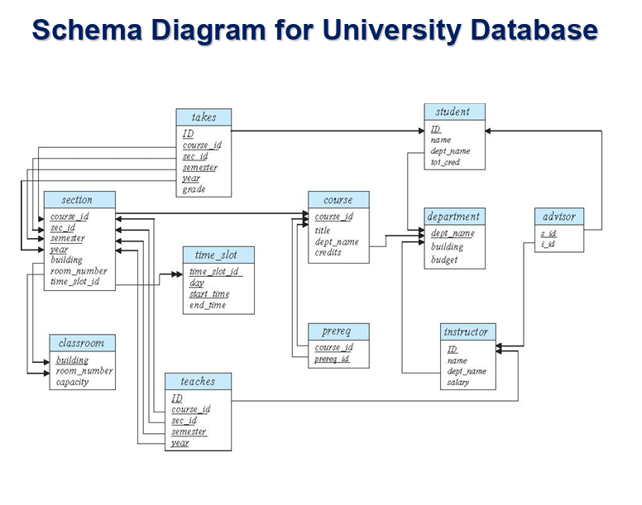
Ans) select i.ID, i.name, COUNT(t.sec_id) AS num_sections
from instructor i
LEFT JOIN Teaches t on i.ID = t.ID
GROUP BY i.ID, i.name
ORDER BY i.ID
Instructor -> Main table with all teachers
Teaches - > show which instructor taught which section
LEFT JOIN -> to get all the columns from instructor table, shows even instructors who haven’t taught any classes still appear
Group by groups results instructor id and name

- Consider the bank database of Figure 1. What are the appropriate primary keys?
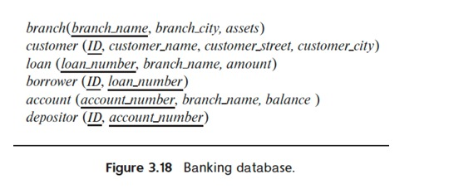
Ans) Primary keys:
branch - > branch_name
customer -> ID
loan -> loan_number
borrower -> ID
account -> account_number
depositor -> ID, account_number

- Construct the SQL queries to find …
a. Find all customers who have an account at all the branches located in “Brooklyn”.
b. Find out the total sum of all loan amounts in the bank.
c. Find the names of all branches that have assets greater than those of at least one branch located in “Brooklyn”.
Ans)
- select c.customer_name
from customer c
where not exists (
select b.branch_name
from branch b
where b.branch_city = ‘Brooklyn’
and not exists (
select a.account_number
from account a
join depositor d on a.account_number =d.account_number where a.branch_name = b.branch_name and a.ID = c.ID
));
- select SUM(amount) as Total_amount
from loan;
- select b1.branch_name
from branch b1
where b1.assests > ANY(
select b2.branch_name
from branch b2
where b2.branch_name = ‘Brooklyn’
);

- Why null values?
Ans) We use null values when the data is missing, unknown or inapplicable. It does not mean that the value is zero or empty string, it’s just the field has no value. For example, in a student table some student’s number Is not there which mean it’s null.
We use null by (IS NULL) or (IS NOT NULL). We don’t use null = null because it’s false.
Null values can affect calculations and conditions, so they must be handled carefully.
- Construct an ER diagram!
- Normalization?
Ans) Normalization is the process of arranging data in a database so that there is no repetition and data stays correct and organized. It divides larger tables into smaller tables and connects them using keys. This help to remove duplicate data, reduce errors and make updates easier.
- 1NF (First Normal Form): Each column should only have one value (no repeating groups)
- 2NF (Second Normal Form): it must be in 1NF, and all columns must depend on the whole key.
- 3NF (Third Normal Form): it must be in 2Nf, and no column should depend on another non-key column.
- BCNF (Boyce-Codd Normal Form): Every deciding column must be a candidate key.

- Compute F+, functional dependency closure from the following set F?
Ans) Computer F plus or Functional dependency closure is the set of all functional dependencies derived from F using Armstrong’s axioms. And F is a set of functional dependencies. So by repeatedly applying Armstrong’s axioms
1) reflexivity: if Y ⊆ X then X → Y This means that a set determines its own subset
2) augmented: XZ -> YZ. The same attributes can be added on both sides
3) transitivity: X->Y and Y->Z the X->Z. If x determines y and y determines z then x will determine z.
On F until we can’t make functional dependencies then we get F plus. And the reason we use F plus is find candidate keys, normalization levels and for lossless decomposition in database design.

- Graph Database and Relational Database?
Relational Database | Graph Database
Stores data in the form of tables made of rows and Columns | Stores data in nodes (entities) and edges (relationships).
Relationships are show using foreign keys and handled by Joins. | Relationships are direct connections between nodes which are edges, and traversal Is fast
Uses SQL for queries | Uses Cypher, Gremlin etc for graph queries
Best for structured and tabular data (e.g., banking, payroll). | Best for highly connected data (e.g., social networks, recommendations).
Data model are rigid and must follow a defined schema. | Data model is flexible, schema-less, and allows dynamic relationships.
Examples: MySQL, Oracle, PostgreSQL | Examples: Neo4j, Amazon Neptune, ArangoDB
Ans)

- Neo4j and graph database concepts as covered in the presentations!
Ans) Neo4j is a graph database which uses LPG ( labeled Property Graph) model for storing and managing data. In this model the data is stored using nodes, relationships and properties.
- Nodes: These are real world entities for example, students, courses , etc.
- Relationships: These are the connections between nodes which are also called edges.
- Properties: These are the key-value pairs which stores the data of nodes and relationships.
Neo4j uses specialized query language called cypher. Which is designed for expressing graph patterns in an easy-to-write format.
Ex MATCH (i:Instructor)-[:TEACHES]->(c:Course)
RETURN i.name, c.course_name;
Neo4j efficiently handles highly connected data using index-free adjacency, which allows direct access from one node to its connected nodes without the help of joins. Because the nodes are directly connected to each other and the traversal is faster as well. That is why larger connected data is best used using neo4j, Most of the social media apps, Linkedin recommendations work using index-free adjacency where relationships are more important than table structure.

- Consider the University database of Figure 2. Develop the Labeled Property Graph (LPG) model for the University database.
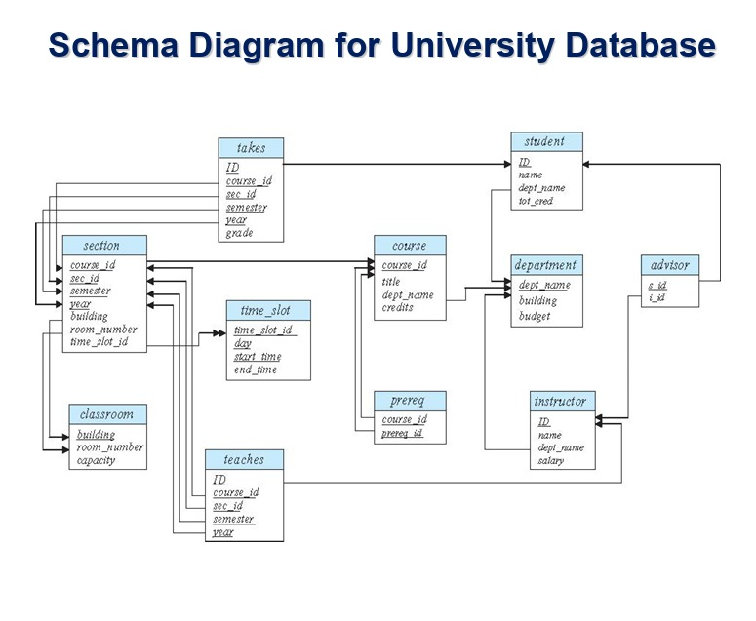
Ans) Labeled Property Graph (LPG) is a model which uses entities as nodes and relationships as edges and properties as key-value pairs which is the data stored about nodes and edges.
Nodes (Entities):
- Instructor → properties: ID, name, salary, dept_name
- Student → properties: ID, name, tot_cred, dept_name
- Department → properties: dept_name, building, budget
- Course → properties: course_id, title, credits, dept_name
- Section → properties: course_id, sec_id, semester, year, building, room_number, time_slot_id
- Classroom → properties: building, room_number, capacity
Relationships (Edges):
- (Instructor)-[:TEACHES]->(Section)
- (Student)-[:ENROLLED_IN]->(Section)
- (Course)-[:OFFERED_BY]->(Department)
- (Section)-[:BELONGS_TO]->(Course)
- (Student)-[:ADVISED_BY]->(Instructor)
In this graph the real world entities are nodes and the relationships between them are edges and allowing faster traversal and easier visualization compared to relational databases. Relationships are written in cypher language in Neo4j.

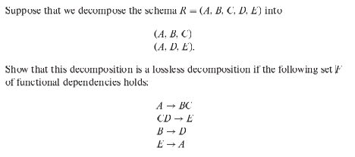
Ans) we have to check the lossless condition but before that we have to check if we have common attributes
R1(A,B,C) and R2(A,D,E).
common attribute is A
and A -> BC then (A,B,C) and CD -> E then (A,B,C,D, E) so Aplus = {A,B,C,D,E}
A determines everything. A is the candidate key for R.
Lossless condition is (R1 intersection R2) ->R1 or (R1 intersection R2) -> R2
As we can A is shared and it determines everything so it is lossless!!!
Feature | Lossless Decomposition | Lossy Decomposition
Meaning | The original relation can be perfectly reconstructed by joining the decomposed tables. | The join of decomposed tables gives extra or wrong (spurious) tuples.
Data Accuracy | No data is lost or changed — information is preserved. | Some information is lost or new unwanted data appears.
Condition | If the common attributes between tables functionally determine all attributes of at least one table, i.e. (R₁ ∩ R₂) → R₁ or (R₁ ∩ R₂) → R₂. | If the common attributes do not determine any of the tables.
Result after Join | Returns exactly the original relation. | Returns extra tuples (spurious results).
Example | R(A,B,C) → R₁(A,B), R₂(A,C) with A → B is Lossless. | R(A,B,C) → R₁(A,B), R₂(B,C) with A → B is Lossy.
- A regular graph and a knowledge graph!
Ans)
Feature | Regular Graph | Knowledge Graph
Meaning | A structure made up of nodes and edges that show simple connections between entities. | A semantic graph that represents entities along with their meaning, relationships, and context.
Data Type | Stores structural data (just how things are connected). | Stores factual and conceptual knowledge about real-world entities.
Representation | Shows direct links between nodes (e.g., friends, roads). | Adds labels, properties, and types to nodes and relationships to describe their meaning.
Purpose | Used for simple network or relationship analysis. | Used for reasoning, understanding, and answering questions intelligently.
Example | A social network graph showing who is connected to whom. | Google Knowledge Graph showing that “Paris” is a city, capital of France, and has Eiffel Tower.

- taxonomy and ontologies!
Ans) Difference Between Taxonomy and Ontology
Point | Taxonomy | Ontology
1. Meaning | A simple classification system that organizes concepts into a hierarchical order. | A knowledge representation model that defines concepts, their relationships, and rules among them.
2. Structure | Has a tree-like structure with “is-a” relationships (e.g., Animal → Mammal → Dog). | Has a network structure that connects concepts using different types of relationships like part-of, owned-by, treats, etc.
3. Purpose | Used mainly for grouping and categorizing information. | Used for reasoning, data integration, and semantic understanding in AI systems.
4. Relationship Type | Only hierarchical relationships. | Includes hierarchical, associative, and logical relationships.
5. Complexity | Simple and easy to build. | More complex and expressive.
6. Example | Biological classification: Animal → Mammal → Human. | Medical ontology: Doctor treats Patient, Disease affects Organ.

- Labeled Property Graph (LPG)
Ans) A Labeled Property Graph (LPG) is a data model used in graph databases such as Neo4j to represent data as nodes, relationships, and properties. Each node represents an entity, such as a student, course, or instructor, and can have one or more labels describing its type (for example, :Student or :Course). Relationships are directed connections between nodes and also have labels that describe their meaning, such as :ENROLLED_IN or :TEACHES. Both nodes and relationships can store properties in the form of key–value pairs, which describe additional details—for example, a student node may have {name: 'Visesh', dept: 'CS'} and an enrolled-in relationship may have {year: 2025}. The LPG model is queried using Cypher, a graph query language designed for pattern matching. This model provides a flexible and intuitive way to represent highly connected data, making it easy to visualize and traverse complex relationships in real-world systems such as social networks, recommendation engines, and university databases.

- Index-Free Adjacency !!
Ans)
Index-Free Adjacency is a key concept used in graph databases such as Neo4j to store and access relationships efficiently. In this model, every node directly contains references (or pointers) to the nodes it is connected to, instead of relying on indexes or join operations like in relational databases. This means when the database needs to find connected nodes, it can follow these direct links without searching through indexes or performing costly joins. As a result, queries that explore relationships—such as finding friends of a user or courses a student is enrolled in—can be executed in constant time, regardless of the size of the graph. Index-free adjacency makes graph databases extremely fast for relationship traversal and is one of the main reasons they outperform relational databases for highly connected data.

